Assignment - 2

|  |  |
| --- | --- |
| **Student Name/ID Number:** | Ida Bagus Ketut Yoghantara |
| **Unit Number and Title:** | ACWD Module 5 – Web Development Foundations |
| **Academic Year:** | 2022 |
| **Unit Assessor:** | Arvinder Kaur |
| **Project Title:** | Setup Spring project, Develop Models & Views. |
| **Issue Date:** | 6 September 2022 |
| **Submission Date:** | 7 September 2022 |
| **Internal Verifier Name:** |  |
| **Date:** | 7 September 2022 |

Date:

Student signature:

I certify that the work submitted for this assignment is my own and research sources are fully acknowledged.

**Learner declaration**



7 September 2022

|  |
| --- |
| **Purpose of this project** |
| **Purpose of this project**  To demonstrate your capabilities in the following areas:   * Create Models & Views |
| **Submission Format** |
| 1. Screen capture of Views 2. Sources of Models |
| **Project Brief & Guidance** |
| **Scenario:**  **Refer to the Project Scenario for the Module Project**  You have been approached by ‘ABC Jobs Pte Ltd’ as a website developer to develop a community portal for Software Developers. The project will be carried over through Module 3, Module 4, Module 5 and Capstone project. For this module the scope is to Design, Develop, Implement & Document Spring Framework Website.  The Scope of the Project is to design a Community Portal Similar to Linkedin.com. Users will be able to register in the portal using the Registration Page. Users of the portal can search for other users using various parameters such as First Name, Last Name, Company Name, City & Country. Users will be able to view the Public Profile of users after searching them. The portal allow users to login, request for forgotten password and Update their profile information  The scope of the project in this modules is for development of Spring Framework Website.  The scope of the project in this modules is to develop the database.  **The overview of the project is as below**  There are 2 types of users in this Community portal. They are   1. Software Programmer 2. Administrator   **Software Programmer should be able to perform following functions in the portal**  1. Allow the programmers to register in the portal, show a thank you page & send a registration confirmation email. |

|  |
| --- |
| 1. Search & Find Other Programmers after login and view their profile. 2. Provide Login Page 3. Provide password retrieval functionality. 4. Update their Profile after logging in.   Following Functionality is part of Database Design & Will be enhanced as features as required in the Capstone Project, Depending on time availability.   1. Send Messages to Each Other on the Portal 2. Create Threads & Post Replies to a Thread 3. Post Job Opportunities in the Portal   **Administrator should be able to perform following functions in the portal**   1. Administer user data. 2. Send bulk email inviting programmers to register on the community portal   **The portal consist of the following Key pages (For Reference)**   1. Community Portal Home Page 2. Registration Page 3. Registration Confirmation Page 4. Update Profile Page 5. Search Users Page 6. List Search Results 7. Public Profile Page 8. Registration Confirmation Email 9. Login Page 10. Forget Password Page 11. Design the Forget Password Confirmation Page   Following Functionality is part of Database Design and will not be part of development & Will be enhanced as features are required in the Capstone Project, Depending on time availability.   1. Send Messages 2. Read Messages 3. Post in Message Board 4. List Message Board 5. Read A Thread 6. Post Job Opportunities 7. List Job Opportunities & Responses   **The scope of this assignment**  The scope is to setup a Spring Project, Create all the Spring Forms for the following functionality   1. Allow the programmers to register in the portal, show a thank you page & send a registration confirmation email. 2. Search & Find Other Programmers after login and view their profile. 3. Provide Login Page 4. Provide password retrieval functionality. |

1. Update their Profile after logging in.

The site does not need a backend integration (Back end integration will be done in Mini Project 3), but all other display views, java script validations, url mappings etc.

* 1. Provide screen capture of HTML Pages with Spring forms.
  2. Provide sources of Models

1. Allow the programmers to register in the portal, show a thank you page & send a registration confirmation email.

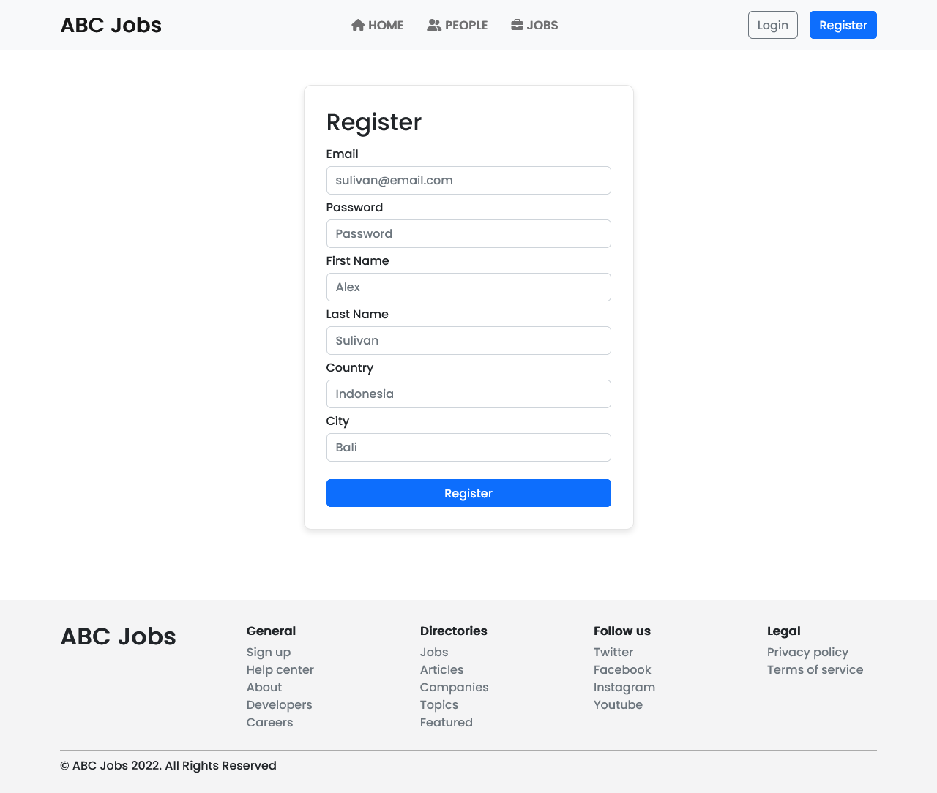

1. Search & Find Other Programmers after login and view their profile.

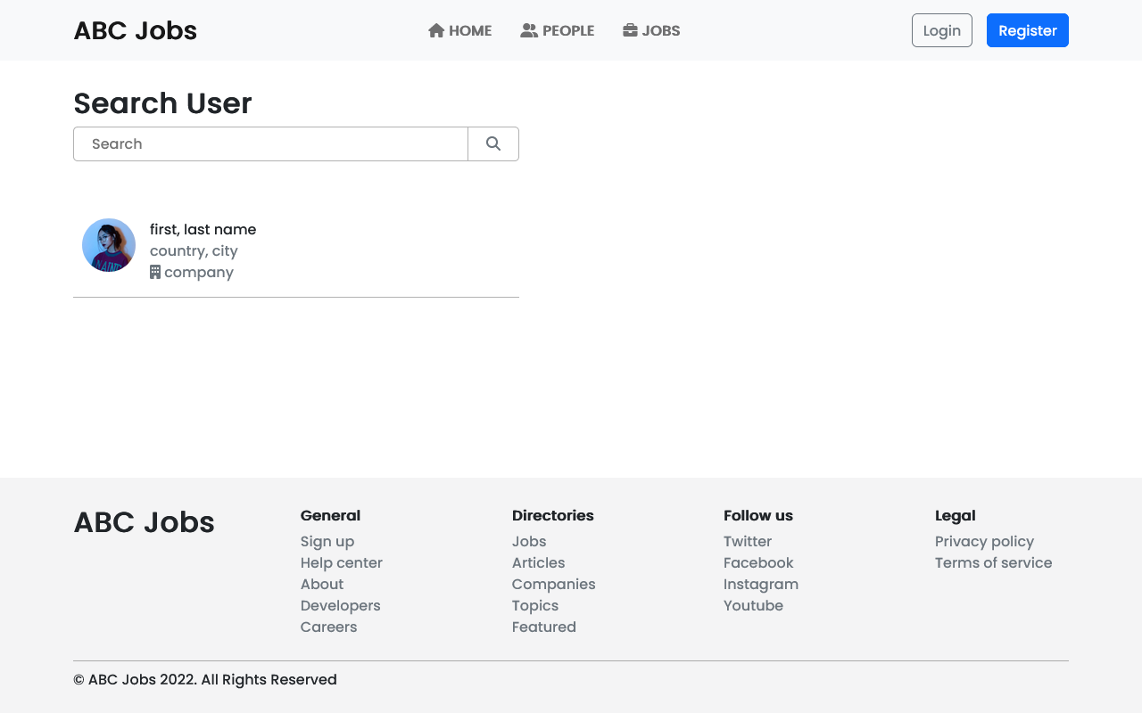

1. Provide Login Page

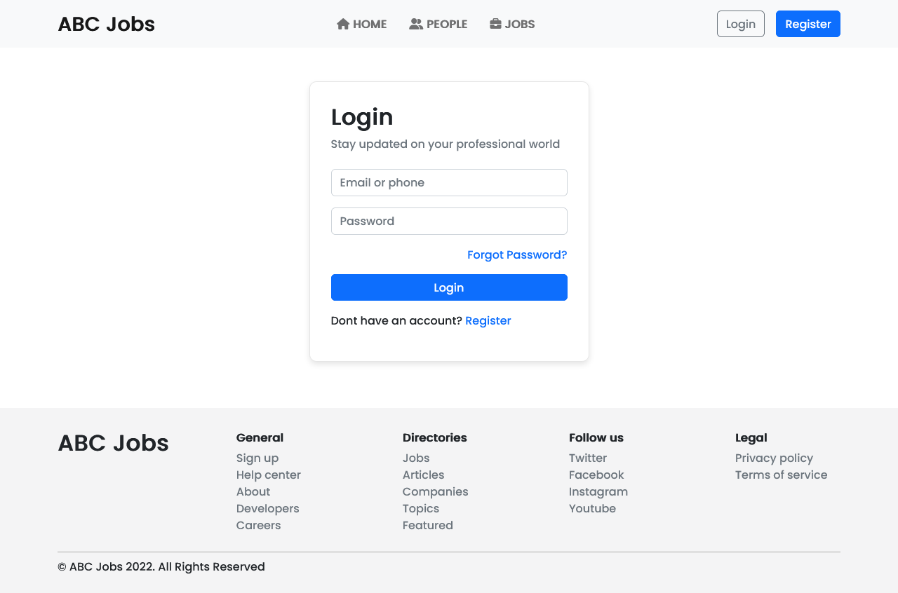

1. Provide password retrieval functionality.

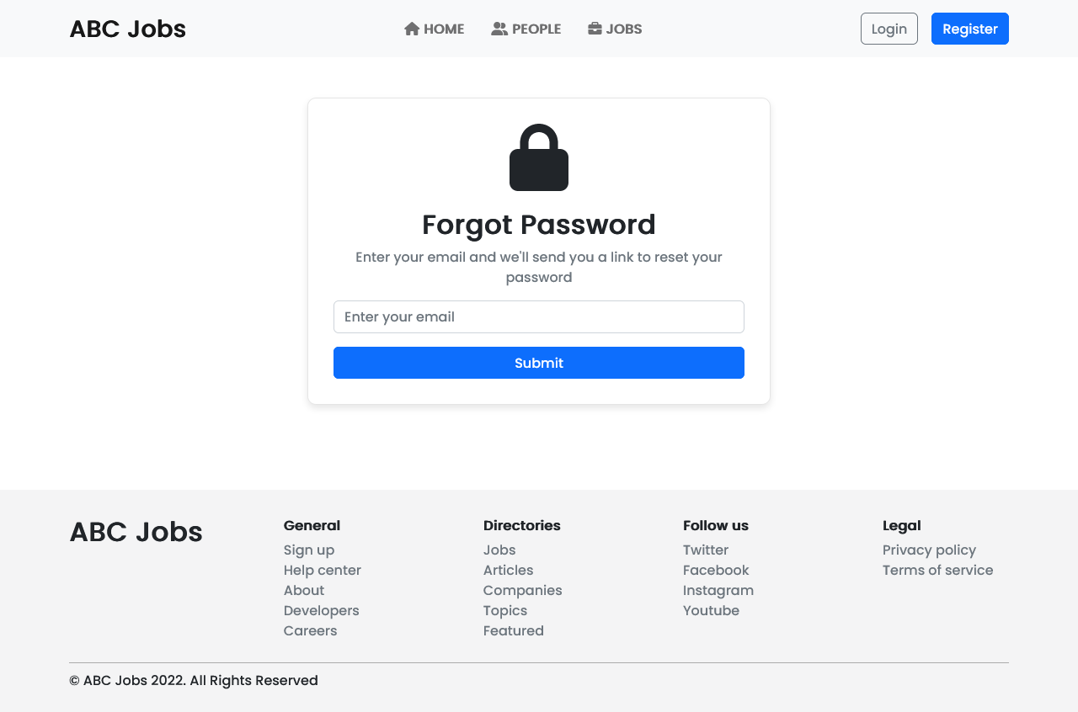

1. Update their Profile after logging in.

